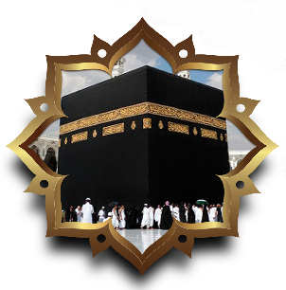
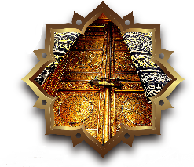

Smart VIP Hajj Package

- Departure: Estimate Departure Date from Canada is: August 2, 2019
- RETURN: Estimate Return Date from Jeddah, Saudi Arabia is: Aug 20th, 2019
- MEMO: Traveling dates are subject to modification due to updates from the Ministry of Hajj, airline arrangement and Hijri Calendar.
Package accommodation
MADINAH Anwar Al Madinah Mövenpick / Pullman Zamzam Hotel Across from Al-Masjid An-Nabawi
MAKKAH Pullman Zamzam / Mövenpick Hajar Tower & Clock Tower Hotels Across from Al-Haram

Package Main Feature
- All Inclusive – Only 5 Stars hotels accommodation in Madinah and Makkah- No Azizia – fees in Can Dollars – No Hidden Fees – Madinah First Package – Smart Eco Services
- Roundtrip airfare from Toronto and Montreal VIA Turkish and Royal Jordanian airlines (other departure cities – additional charges apply) (exact Flight Itinerary soon will be provided).
- 3 Nights in Anwar Al Madinah Mövenpick – Across from Al-Masjid An-Nabawi in Madinah – 5 Stars
- 5 Nights in VIP Mena camp (solid drywall air-conditioned tents) located right across from Jamarat(short walk)
- 9 Nights in Mövenpick Hajar Tower – Across from Al-Masjid Al-Haram – 5 Stars
(estimated about 3 nights before and 6 nights after Hajj)
- Keep your hotel’s room during the days of Hajj, (since you arrive till departure Makkah).
- Open buffet Smart breakfast and dinner catered by top-ranking ministry approved catering firm (Mina and Arafat)
- VIP Breakfast and dinner served via open buffet concepts in Makkah and Madinah.
- Private Smart VIP air-conditioned buses for transfers between cities and Mazarat -sightseeing
- Guided Mazarat -Sightseeing tour in Madinah
- Religious Guidance & supervision provided by leading experienced Imams in Arabic, English, French, Somali, and Urdu throughout the Hajj journey.
- Support service team available 24 hours.
- Complimentary Premium VE Travel Hajj kit(Backpack, Sun umbrella, personalized luggage tags, also (for Men ihram and Misk), and (Hejab for women).
- Hajj Mutaweef Payment – Sacrifice (Udhiya- Qurbani) –* Saudi Both Taxes 10% – all Included
PACKAGE COST IN CAD Per Person: Tax included
$13,850 in Quad $14,350 in Triple $14,850 in Double
Registration process: (Frist come first service)
- Submit the registration from link below.
- Submit copy of your passport
- Pay your first deposit ($2000), in order to save your spot.
- Follow up the required documentations and payment schedule (will be email it to you).
- IMPORTANT! As per the Ministry of Hajj; Those who performed Hajj in the past 3 years are subject to an additional SR 2000 Hajj visa fee (Approx. $750 CAD). This fee is charged when issuing the visa.
Contact information
e-mail | ottawa@visaenterprise.com
Phone | (613)232-6565
Office address | 116 Albert St. Unit 405, Ottawa, ON, K1P 5G3
Website | www.visaenterprise.com
 | www.labaykhajj.com

